Please Follow Below Mentioned Instructions for Filling CV
- Do not change the format of the CV.
- Use Font: Times New Roman & Font Size: 12
- Do not use complete upper case while filling data.
- The passport size photograph should be in uniform (No selfie) with plain background. 70 to 75 % of photograph area should be covered by face.
- Convert the document in to PDF format & use for further procedures.
- Delete this page before sending the CV to Placement cell or to any company.



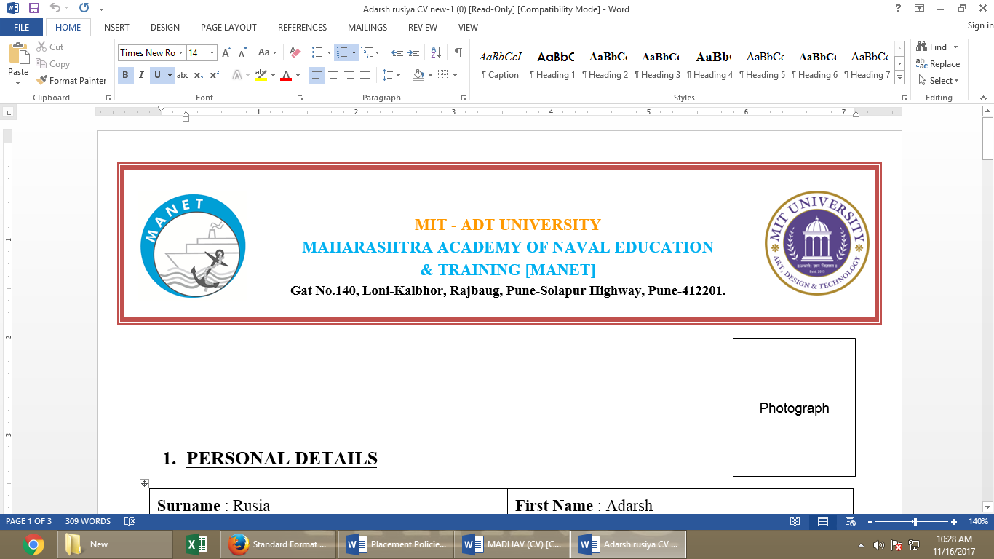 | MIT Art, Design & Technology University  Maharashtra Academy of Naval Education & Training, MANET  Gat No.140, Loni-Kalbhor, Rajbaug, Pune-Solapur Highway, Pune-412201.

Passport Size Photo
in MANET
Uniform
With plain background

Personal Details:
Surname: | First Name: | Middle Name:
Nationality: Indian | Date of Birth: 29th Jan, 1992 | Place of Birth: Pune, Maharashtra
Weight: 68 Kg | Height (cm): 160 cm | BMI: 24.3
Post Applied For: Trainee Marine Engineer (TME)/ Deck Cadet

Academic Qualifications:
Qualification | Passing Year | Percentage | Board/ University
B. Tech. Marine Engineering | 2018 | 88 | MIT-ADTU
XIIth | 2014 | 88.23 (PCM) | Maharashtra
Xth | 2012 | 92.01 | Maharashtra

Passport Details:
Passport No | Date of Issue | Place of Issue | Date of Expiry | ECNR | Blank Pages
Z1234567 | 15th May, 2019 | Pune, India | 14th May, 2019 | Y/N | 36

Continuous Discharge Certificate/Indos No: Indian
Number | Date of Issue | Place of Issue | Date of Expiry | Remark
CDC: MUM123456 | 15th May, 2019 | Mumbai, India | 14th May, 2019
Indos: 19EL0000 | 6th Sep, 2015 | Mumbai, India

Details of B. Tech Marine Engineering Course:
Semester | Percentage | Average
Semester VIII
Semester VII
Semester VI
Semester V
Semester IV
Semester III
Semester II
Semester I

Details of STCW Courses:
Details of Courses and Certificates | Issued By | Number | Date of Issue | Place of Issue
Elementary/ Medical First Aid/ Medicare | Seacom Marine College | SMCC/EFA/3413 | 3rd Jan 2017 | Kolkata
Personal Safety & Social Responsibility
Fire Prevention and Fire Fighting
Personal Survival Techniques
Security Training for Sea Farers With Designated Security Duties
Petrol Tanker Familiarization
Chemical Tanker Familiarization
Gas Tanker Familiarization

Dangerous Cargo Endorsement:
Dangerous Cargo Endorsement | Grade/ Level  I/II | Number | Date of Issue | Place of Issue | Date of Expiry
Details of Extra-Curricular Activities:
Sr. No. | Details of Certificates
1. | Certificate of Participation and Winning Inter-Maritime NAUGHTICA 2018 Battle of Bands Competition.
2. | Certificate of Securing 1st Place in Mega Jam: Musical Band Contest Event of “MIT Persona Fest 2018”.
3. | Certificate of Participation and Winning Inter-Maritime NAUGHTICA 2017 Battle of Bands Competition.
4. | Certificate of Participation in Republic day Parade and Guard of Honour in the year 2015 and 2016 at Manet, Pune.
5. | Certificate Of Participation In Jamshedpur Short Marathon 2013
6. | Certificate of Securing 2nd Runner Up Position in State Level Battle of Bands Competition of Silver Wheels.

Hobbies and Interests:
Playing Guitar, Music Composing, Photography and Video Editing etc.

Family Background:
Any Relative in Marine Field: If yes (His/ Her Name, Designation and Company Name)

Location Details:
Present Address: |  | Permanent Address:
Landmark: | Pin code: | Landmark: | Pin code:
Mobile No (What’s app): |  | Parents Mobile No:
Alternative No: |  | Alternative No:
Email ID: abc123@gmail.com

Declaration:
I hereby inform that whatever the information provided by me is true and to the best of my knowledge and belief; further, that no certificate issued to me has never been revoked or suspended.

Date: 1st Oct, 2019 Signature:

